Obituaries: Lorin Cassandre Mead
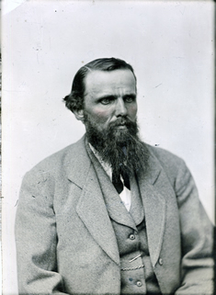
Longmont Ledger
July, 1908
Died
Mead - At his home at Highlandlake, Monday, July 6, 1908, of heart failure, Lorin Casandre Mead, aged 76 years.
It is with regret that we are obliged to chronicle the death of "Deacon" Mead as he has been familiarly known among his friends. He had finished his life's work and has done it well. A sturdy Christian he has fought for the faith in in every day life believing in the great future he has now gone to meet. He was one of the charter members of the Longmont Congregational Church, and soon after assisted in organizing the Church at Highlandlake. He has been serving as deacon since that time.
Mr. Mead was born in the town of Cornwall, Vermont, in 1832, and is consequently 76 years of age. His early life was spent upon a farm, and his education acquired in the public schools and at Castleton seminary. In 1871, when the Longmont colony was organized, Mr. Mead cast his fortunes with it, and came to Colorado. In 1874 (sic-he actually filed on the farm in 1871), he secured the fine farm upon which he now lives at Highlandlake, and had there resided continuously since.
A man of strong opinions and pronounced views, he almost at once assumed a leading position in the community. In 1879 he was elected to the state legislature, where his ability received prompt recognition. He was made chairman of the committee on irrigation, then probably the most important to the welfare of the young State, and by his personal efforts succeeded in getting through both branches the bill which embodies all the important principles of our irrigation laws. By this one act alone Mr. Mead rendered a service which can never be adequately repaid.
During his connection with the legislature he was always found fighting for the measures which would benefit the people and rendered most valuable service to his constituents. He was eminently qualified for the exacting service of molding legislation in the formative period of a young State and his wide knowledge of the necessities of the commonwealth made his advice and suggestions especially valuable.
Probably no man in the State kept in close touch with the tread of public events, or was more capable of correctly diagnosing them. A close student and deep thinker, he always kept fully abreast of the progress of the times.
He leaves two sons, Malcom G. and Rufus of Highlandlake and one daughter, Mrs.. Lettie (Fred F.) Weston of Washington D.C.
Funeral services were held Tuesday at the residence by Revs. Strong and Eckle.
Note: Elizabeth Mead, his wife, also survived him. She died on October 30, 1922. It is unclear why she is not mentioned in his obit.

